# 1. Facility Records

## Figure 1.1: Pairwise Relationships of Quality of Care Metrics by Chain Ownership

Description: This figure displays the pairwise relationships between various quality of care metrics, differentiated by chain ownership status (yes or no). The scatter plots and density plots offer insights into how metrics like mortality rate, readmission rate, facility star ratings, and others correlate with each other based on whether a facility is part of a chain.

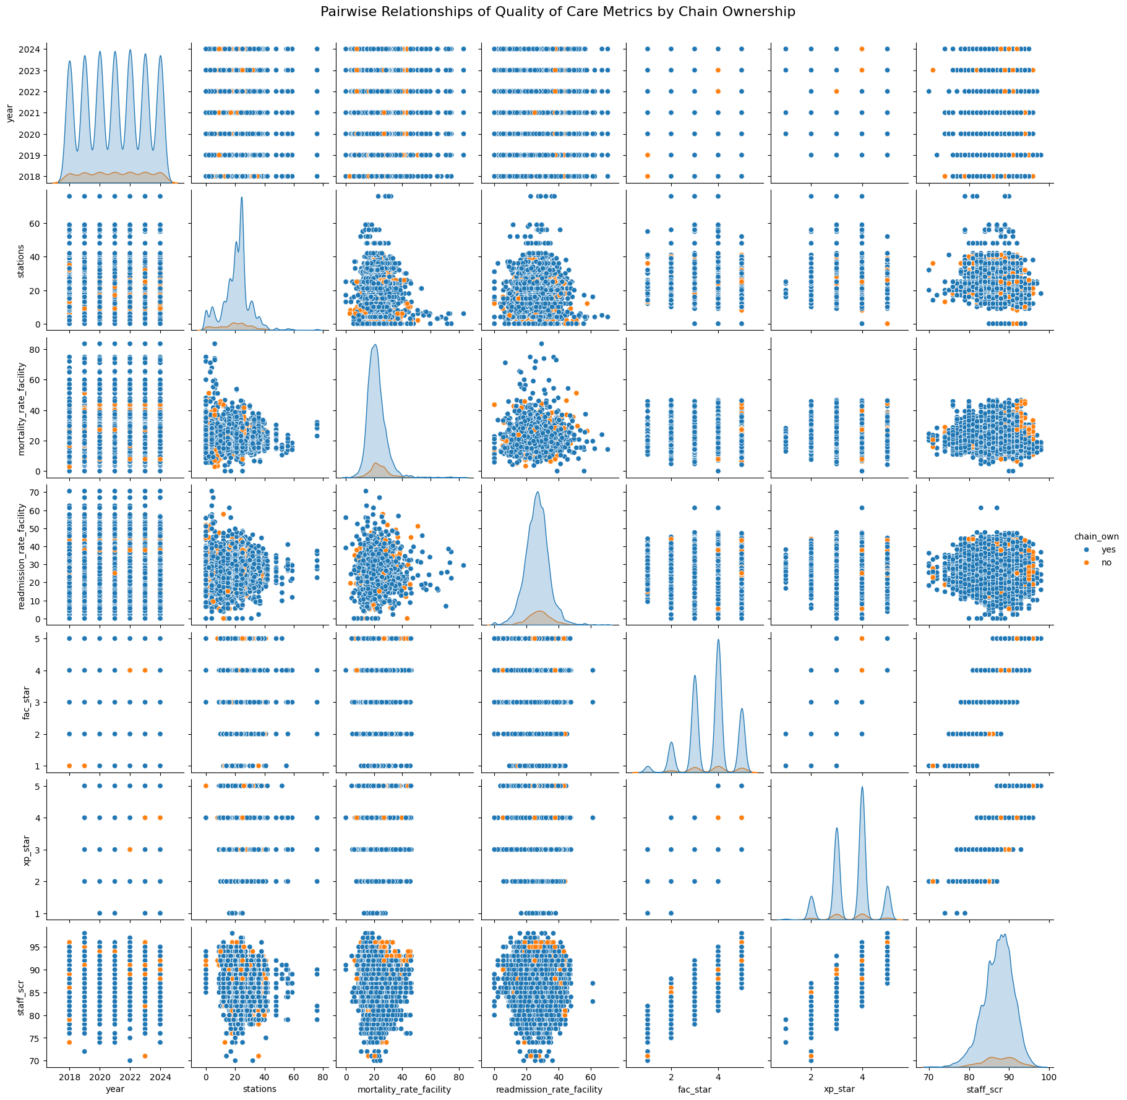

## Figure 1.2: Pairwise Relationships of Quality of Care Metrics by Profit/Non-Profit Status

Description: This figure explores the pairwise relationships between different quality of care metrics for facilities categorized by their profit status (profit or non-profit). The plots provide a visual comparison of trends and correlations in quality metrics such as mortality rate, readmission rate, and star ratings between profit-oriented and non-profit facilities.

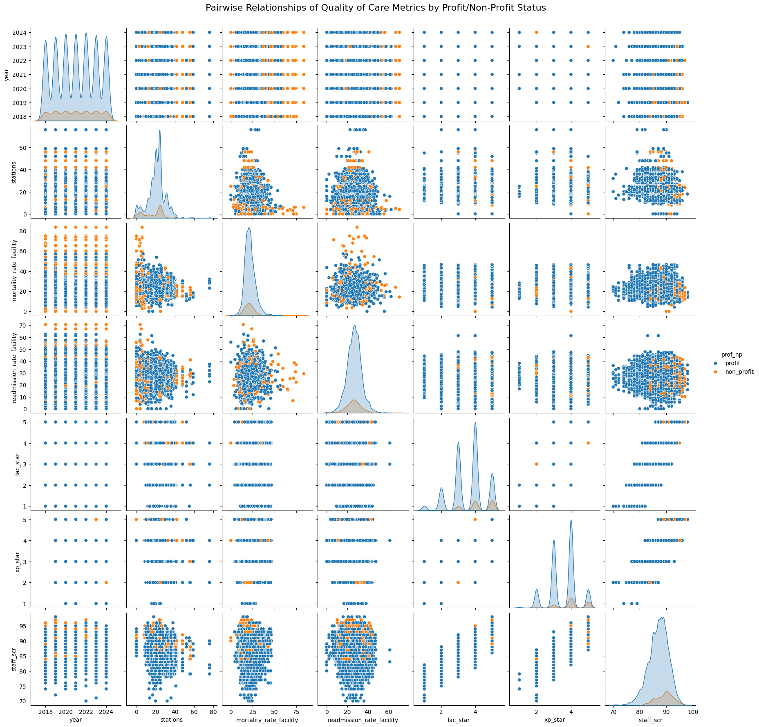

# 2. Geographic Distributions in California

## Figure 2.1: Stations by County in California

Description: This map illustrates the distribution of stations across various counties in California. The color gradient represents the number of stations, with a higher number corresponding to lighter shades.

## Figure 2.2: Facility Count by County in California

Description: This map displays the count of facilities per county in California. The color gradient shows the variation in the number of facilities, highlighting areas with higher concentrations.

## Figure 2.3: Chain Ownership by County in California

Description: This map shows the proportion of chain-owned facilities across counties in California. The gradient indicates the proportion of chain ownership, with darker shades representing higher ownership percentages.

## Figure 2.4: Profit/Non-Profit Ratio by County in California

Description: This map depicts the ratio of profit versus non-profit facilities across counties in California. The gradient shows the distribution of profit-oriented facilities, helping to identify regional variations.

# 3. Race Group Distributions in California

## Figure 3.1: Race Group - White by County in California

Description: This map displays the distribution of the White race group across counties in California. The gradient represents the proportion of the population that identifies as White in each county.

## Figure 3.2: Race Group - Other by County in California

Description: This map shows the distribution of individuals identified as belonging to other race groups across counties in California. The gradient indicates the percentage representation of these groups in each county.

## Figure 3.3: Race Group - Hispanic by County in California

Description: This map illustrates the distribution of the Hispanic population across counties in California. The gradient highlights the proportion of Hispanic residents in each county.

## Figure 3.4: Race Group - Black by County in California

Description: This map presents the distribution of the Black population across counties in California. The gradient shows the percentage of Black residents within each county.

# 4. Age Distribution in California Counties

## Figure 4.1: Age Distribution in Top and Bottom 10 Counties by Average Age

Description: This bar plot compares the age distribution of the top 10 and bottom 10 counties in California based on average age. The left panel represents counties with the highest average ages, while the right panel shows those with the lowest. Each color represents a different age group, providing a clear visual of the age composition in these counties.

## Figure 4.2: Age Distribution in All California Counties (Sorted by Average Age)

Description: This heatmap visualizes the age distribution across all California counties, sorted by the average age. Darker shades represent a lower percentage of the population in specific age groups, while lighter shades indicate higher percentages.

